Day 1: The Sun as a Star
May 12th 2014
1:00 PM-1: 45 PM

Day 2: The Sun as a Star
May 13th 2014
1:00 PM-1: 45 PM

Day 3: The Importance of the Sun
May 14th 2014
1:00 PM-1: 45 PM

Day 4: How the Sun Affects Temperature
May 15th 2014
1:00 PM-1: 45 PM

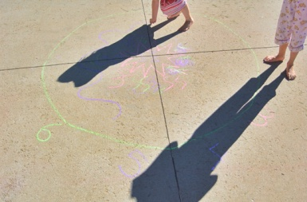
Day 5: Shadows
May 16th 2014
1:00 PM-1: 45 PM

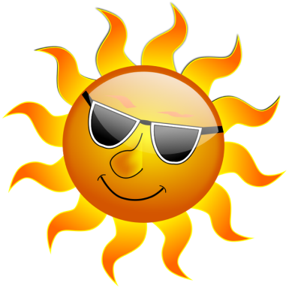
Day 6: The Harmful Aspects of the Sun
May 19th 2014
1:00 PM-1: 45 PM

